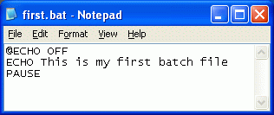
Creating a Batch File
- Click Start, All Programs, Accessories, Notepad.
- Type in the three lines as shown to the right on this page. Save the file on the desktop with the name first.bat – be sure to get the filename extension correct.
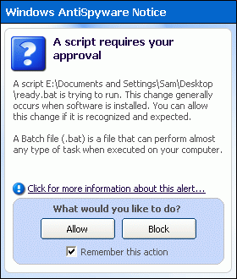
Running a Batch File
- Minimize all windows, if necessary, and find the first.bat icon on the desktop. Double-click that icon to run the batch file.
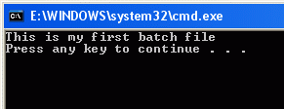
- If a Windows AntiSpyware Notice pops up, saying A script requires your approval, click Allow.
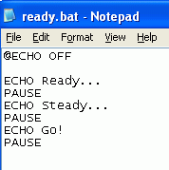
- A window opens containing the text This is my first batch file, as shown to the right on this page. This is the output of the batch file. The text in the title bar will be different. Read the text, then press the Enter key to exit the batch file and close the window.
Creating a Batch File With Two Stages
- Click Start, All Programs, Accessories, Notepad.
- Type in the three lines as shown to the right on this page. Save the file on the desktop with the name ready.bat.
- Double-click the ready.bat icon on the desktop. If a Windows AntiSpyware Notice pops up, saying A script requires your approval, click Allow.
- A window opens containing the word Ready…, as shown to the right on this page. Press the Enter key twice to see the rest of the program.
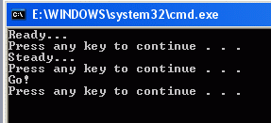
Understanding Batch Files
- Batch files contain commands, one command per line. So far you have used only three commands: @ECHO OFF, ECHO, and PAUSE. These three commands are explained on the other side of the page.

- @ECHO OFF Tells Windows not to bother us with extra messages while the batch file is running.
- ECHO text Prints out text on the screen, where text can be anything you want.
- PAUSE Prints out the message Press any key to continue… and waits.

Creating Your Own Batch File
- Make your own batch file, with your name in the file name. It should have output like that shown in the figure below on this page, replacing YOUR NAME with your own name.
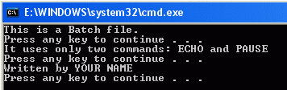

- Save your batch file on a floppy disk and give that disk to the Results Presenter. Explain how it works to the Results Presenter.

Last modified 3-6-06

